

*ChangeLog*

| **Version** | **Change Date** | **By** | **Description** |
| --- | --- | --- | --- |
| version number | Date of Change | Name of person who made changes | Description of the changes made |
| 1 | 1-11-2023 | Anshul Nigam | Initial |
|  |  |  |  |

**1** **INTRODUCTION 2**

1.1 Scope 2

*1.1.1* *In Scope* 3

*1.1.2* *Out of Scope* 4

1.2 Quality Objective 5

1.3 Roles and Responsibilities 6

**2** **TEST METHODOLOGY 6**

2.1 Overview 6

2.2 Test Levels 6

2.3 Test Completeness 7

**3** **TEST DELIVERABLES 8**

**4** **RESOURCE & ENVIRONMENT NEEDS 10**

4.1 Testing Tools 10

4.2 Test Environment 10

**5** **TERMS/ACRONYMS 10**

# **Introduction**

In the realm of automotive safety and cargo monitoring, the integration of cutting-edge technology has brought about significant advancements, with the potential to transform driver safety and cargo integrity. This project aims to enhance driver safety and cargo condition monitoring by developing an IoT-enabled system, bringing together innovative solutions to address critical issues that encompass driver drowsiness, harmful gas detection, and cargo temperature/humidity control.

This project necessitates rigorous and systematic testing to ensure the functionality, reliability, and safety of the IoT device. In this document, we provide a comprehensive insight into the test strategies, processes, workflow, and methodologies employed throughout the project to achieve these goals.

**Test Strategies:**

Our approach to testing revolves around a multifaceted strategy that addresses the diverse aspects of the IoT system:

* **Driver Safety Monitoring:** To ascertain the system's proficiency in detecting driver drowsiness, we implement testing scenarios that mimic real-world driving conditions. Test cases are designed to rigorously evaluate the accuracy and effectiveness of the driver safety features.
* **Harmful Gas Detection:** Testing strategies for harmful gas detection are centered on the reliability and responsiveness of the *MQ-3 sensor*. We aim to ensure that the device can promptly identify the presence of harmful gases, providing timely alerts to prevent health hazards.
* **Cargo Condition Monitoring:** The cargo monitoring aspect focuses on maintaining optimal temperature and humidity for transported goods. Our testing strategies include simulating different cargo conditions and scrutinizing the device's ability to prevent cargo spoilage through timely alerts.

**Test Process:**

The test process adheres to a structured and systematic approach, encompassing the following stages:

* **Test Planning:** This stage involves test strategy formulation, test case identification, and resource allocation. Test objectives, scope, and constraints are clearly defined.
* **Test Design:** Detailed test cases are developed for each aspect of the project, addressing driver safety, gas detection, and cargo condition monitoring. These test cases outline the preconditions, steps, expected results, and pass/fail criteria.
* **Test Execution:** Real-world testing is carried out according to the test cases, with careful data collection and the observation of device behavior under various conditions.
* **Defect Reporting:** Any identified issues or defects are documented, including their severity and steps to reproduce them.
* **Defect Resolution and Retesting:** After defects are addressed, the affected test cases are retested to verify the effectiveness of the fixes.

**Workflow:**

Our testing workflow encompasses a systematic sequence of activities, from initial planning and design to execution and post-test analysis. This workflow ensures the systematic evaluation of the IoT device's functionality and its adherence to safety standards.

**Methodologies:**

The testing methodologies utilized in this project include:

* **Black Box Testing:** Evaluating the IoT device's functionality without knowledge of its internal structure, focusing on inputs and outputs.
* **White Box Testing:** Assessing the internal logic and code of the device to ensure robustness and security.
* **Continuous Integration and Testing (CI/CD):** Ensuring that testing is an integral part of the development process, with regular integration and automated testing.
* **Real-world Simulation:** Simulating real-world driving and cargo conditions to validate the device's performance under various scenarios.

Through this document, we will delve deeper into the specific test cases, results, and findings that form the foundation of our endeavor to ensure the safety of drivers and the integrity of transported goods.

## **Scope**

### In Scope

The scope of test cases forDriver Safety Assistance and Cargo Monitoring IoT project can be defined based on both the features and the functional and non-functional requirements of the software and hardware components.

1. **Driver Safety Monitoring:**

**Features Scope:** Test cases in this category will assess the features related to driver safety, which may include:

* Drowsiness detection algorithms.
* Alert mechanisms, such as sound notifications or visual indicators.
* User interaction with the driver safety system through a mobile app or dashboard.
* Data logging and analysis for driver behavior assessment.

**Functional Requirements:** Test cases will focus on the functional aspects, ensuring that the system accurately detects signs of drowsiness and responds appropriately.

**Non-Functional Requirements:** These may involve latency in alert generation, system responsiveness, and reliability in various driving conditions.

1. **Harmful Gas Detection:**

**Features Scope:** Test cases for gas detection encompass the following features:

* Calibration and accuracy of the MQ-3 sensor.
* Timely detection of harmful gasses, such as carbon monoxide (CO) and methane (CH4).
* Alerts and notifications to the vehicle owner or driver.
* Sensor fault tolerance and self-diagnostic capabilities.

**Functional Requirements:** Testing will ensure that the sensor accurately detects the presence of harmful gasses and that alerts are triggered as expected.

**Non-Functional Requirements:** These may involve the sensor's precision, response time, and maintenance requirements.

1. **Cargo Condition Monitoring:**

**Features Scope:** Test cases related to cargo monitoring will encompass features like:

* Temperature and humidity monitoring systems.
* Alert generation for cargo conditions outside specified ranges.
* Real-time cargo condition data presentation through the app or dashboard.
* Data logging for historical cargo condition analysis.

**Functional Requirements:** These test cases will validate the functionality of the cargo monitoring system, including temperature and humidity measurement accuracy and alert triggering.

**Non-Functional Requirements:** This may involve the system's data storage capacity, data retrieval speed, and energy efficiency in long-haul transportation.

1. **V-Saathi App:**

**Features Scope:** Test cases related to V-Saathi will encompass features like:

* Login Authentication using Firebase
* Fetching correct details from Firebase
* Updating Values from the App.
* Notification Alert

**Functional Requirements:** These test cases will validate the functionality of App Login, Data Display, integration with the Software, and Alert notification.

**Non-Functional Requirements:** This involves system performance and Real-time no lag display of data.

1. **Integration Testing:**

**Features Scope:** Integration test cases focus on the interaction between different components of the system, ensuring seamless communication between the driver safety, gas detection, and cargo monitoring modules.

**Functional Requirements:** These tests assess how well the different modules work together, confirming that they share data and respond cohesively.

**Non-Functional Requirements:** This may involve the system's overall performance and resource utilization during simultaneous monitoring tasks.

### Out of Scope

### **Voice Recognition:**

**Out of Scope:** Testing the system's compatibility with voice recognition technology for driver commands is not within the scope of this project.

1. **Wireless Connectivity Standards Beyond Wi-Fi and Bluetooth:**

**Out of Scope:** Evaluating the device's compatibility with wireless connectivity standards like 4G/5G or specific proprietary protocols falls outside the scope of this project.

1. **Legal Compliance and Certification:**

**Out of Scope:** Ensuring the device complies with legal regulations and industry certifications is not part of the testing scope. This typically involves separate certification processes.

1. **Real-time Remote Control of Vehicle Functions:**

**Out of Scope:** Testing the ability to remotely control vehicle functions (e.g., engine shutdown) through the IoT device is not included in the scope.

## **Quality Objective**

**Overall Testing Objectives:**

1. **Validate Functional and Non-Functional Requirements:**

Ensure the Application Under Test (AUT) conforms to both functional and non-functional requirements. This includes verifying that all specified features related to driver safety, gas detection, and cargo monitoring are working as intended and that non-functional aspects like performance, security, and scalability meet predefined criteria.

1. **Quality Assurance and Compliance:**

Verify that the AUT meets the quality specifications defined by the client or project stakeholders. This includes ensuring that the system operates reliably, accurately, and consistently under various conditions, aligning with the client's quality expectations.

1. **Early Identification of Bugs and Issues:**

Detects and rectifies bugs, defects, or issues within the IoT system before it goes live or is deployed to real-world environments. By identifying and addressing these issues during testing, the project aims to prevent potential problems that could impact driver safety or cargo integrity.

1. **Enhanced Safety and Cargo Integrity:**

Ultimately, the overarching objective is to enhance safety for drivers and protect the integrity of transported goods. The testing process seeks to ensure that the system operates flawlessly, detecting drowsiness, harmful gasses, and cargo conditions accurately and promptly.

1. **Risk Mitigation:**

Mitigate risks associated with the IoT system's deployment by identifying and addressing issues during the testing phase. This includes reducing the risk of false alarms, inaccurate readings, and system failures that could compromise safety and cargo conditions.

1. **User Satisfaction and Confidence:**

Instill confidence in end-users, whether they are vehicle owners, drivers, or other stakeholders, by delivering a thoroughly tested and reliable IoT system. Meeting or exceeding user expectations for safety and cargo condition is paramount.

1. **Efficiency and Cost Savings:**

Achieve efficiency by identifying and addressing issues early in the development process, potentially saving time and resources that would otherwise be spent on post-deployment fixes and maintenance.

## **Roles and Responsibilities**

* **QA Analyst:**
  + Anshul Nigam
  + Nikita Jain
* **Test Manager:**
  + Ms. Akanksha
  + Ms. Shreela Pareek
* **Configuration Manager:**
  + Ms. Pallavi Sharma
  + Ms. Neha Shukla
* **Developers**
  + Anshul Nigam
  + Abhinav Tripathi
* **Installation Team**
  + Anshul Nigam
  + Nikita Jain

# **Test Methodology**

## **Overview**

The adoption of an Agile methodology for the "Truck Driver Safety Assistance" project emerges from the inherent complexity of its technological components, including the integration of IoT and Flutter-based mobile application technologies. This dynamic approach is essential for handling the diverse requirements of real-time driver safety and cargo monitoring. The Agile methodology's flexibility and iterative nature allow seamless adaptation to the complexities of IoT sensor data collection, analysis, and presentation through the Flutter-based mobile application, "Saathi." By embracing an Agile approach, the project ensures continual testing and adaptation. The technology's complexity requires ongoing adjustments based on evolving requirements, user feedback, and the dynamic nature of the transportation sector, making Agile the ideal choice to ensure the reliability and efficiency of this multifaceted system.

## **Test Levels**

The testing to be performed is Manual Testing.The testing is performed by the developers' team along with QA and Configuration Manager.

**Unit Testing:**

Scope: Individual components and functions of the truck driver safety assistance.

Objective: To verify that each component/sensor works correctly and give the accurate output.

Testing Approach: Developers and hardware engineers conduct unit tests to validate the accuracy of the sensors/system at a granular level.

**Integration Testing:**

Scope: The interactions and interfaces between various components and frameworks used in the project.

Objective: To ensure that the integration of different components does not introduce errors or inconsistencies in the data processing.

Testing Approach: Developers and testers assess the data flow and interactions between components and detect any integration issues.

**Functional Testing:**

Scope: The complete truck driver safety assistance.

Objective: To validate that the system functions according to specified requirements and that it performs an accurate solution.

Testing Approach: Testers execute functional tests by providing input sensor data and verifying that the output gives alert at the false data.

**Security Testing:**

Scope: The system's security mechanisms, especially for handling user data.

Objective: To identify and mitigate potential security vulnerabilities, including data breaches and unauthorized access.

Testing Approach: Security testing includes penetration testing, data encryption checks, and access control assessments.

**Regression Testing:**

Scope: The entire system after updates or changes.

Objective: To confirm that new changes or enhancements do not introduce defects or negatively impact existing functionality.

Testing Approach: Automated regression tests are executed to validate that previously tested features still work as expected.

## **Test Completeness**

For instance, a few criteria to check Test Completeness would be

* 100% test coverage
* All Manual Test cases executed
* All open bugs are fixed or will be fixed in the next release
* All content and style transfer tests have been executed, ensuring that various input sensor data have been processed successfully and meet the defined output and give alert.
* 30% Regression tests have been executed, and previously tested features still work as expected after updates or changes.

# **Test Deliverables**

**Test Cases**

| **S.No.** | **Test Data** | **Expected Output** | **Actual Output** | **Pass/Fail** |
| --- | --- | --- | --- | --- |
| 1 | User Login | Authenticated user can log in | Unauthorized user can't log in | Pass |
| 2 | Eye Blink No. | Drowsiness Detected | Drowsiness Detected | Pass |
| 3 | Cargo environment | Temperature and humidity alert | Alert when environment condition doesn't satisfy | Pass |
| 4 | Gas measure | Harmful gas Detected | Harmful gas alert | Pass |

**Decision Table For User Login**

| **Test Case** | **User Name** | **Password** | **Expected Output** | **Actual Output** |
| --- | --- | --- | --- | --- |
| 1 | Wrong user name | Wrong Password | Invalid User | Invalid User |
| 2 | Wrong user name | Correct Password | Invalid User | Invalid User |
| 3 | Correct user name | Wrong Password | Invalid User | Invalid User |
| 4 | Correct user name | Correct Password | Login Successful | Login Successful |

**Boundary Value Analysis For Sensors Data**

* **For Eye Blink Sensor**

**Ranges**

| Min=0 |
| --- |
| Min+1=1 |
| Mid=12 |
| Max=21 |
| Max-1=20 |

| **Test Case No.** | **Input** | **Expected Output** | **Actual Output** |
| --- | --- | --- | --- |
| 1 | 5 | No Alert | No Alert |
| 2 | 8 | No Alert | No Alert |
| 3 | 20 | No Alert | No Alert |
| 4 | 23 | Alert | Alert |

* **For MQ3 Gas Sensor**

**Ranges**

| Min=25ppm |
| --- |
| Min+1=26ppm |
| Mid=250 ppm |
| Max=500ppm |
| Max-1=499 ppm |

| **Test Case No.** | **Input** | **Expected Output** | **Actual Output** |
| --- | --- | --- | --- |
| 1 | 25ppm | All good | All good |
| 2 | 24ppm | Harmful | Harmful |
| 3 | 499 ppm | All good | All good |
| 4 | 501 ppm | Harmful | Harmful |

* **For DHT11 Sensor Cargo Condition**

**Ranges**

| **Humidity** |  | **Temperature** |
| --- | --- | --- |
| Min=0% |  | Min=0C |
| Max=60% |  | Max=50c |

| **Test Case No.** | **Humidity** | **Temperature** | **Expected Output** | **Actual Output** |
| --- | --- | --- | --- | --- |
| 1 | -10% | 30C | Invalid | Invalid |
| 2 | 20% | 70C | Invalid | Invalid |
| 3 | 10% | 49C | Valid | Valid |
| 4 | 59% | 49C | Valid | Valid |

# 

# Test Case Output

**For User Login**

1. **Unauthorized User 2. Login Successfully**

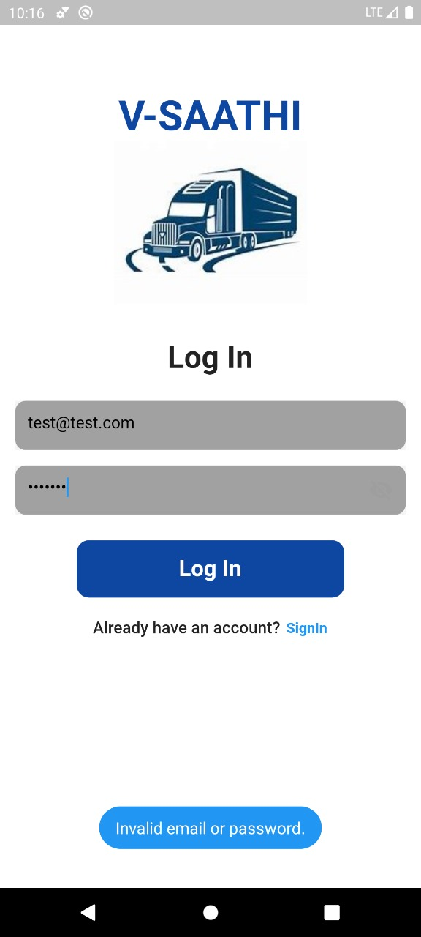 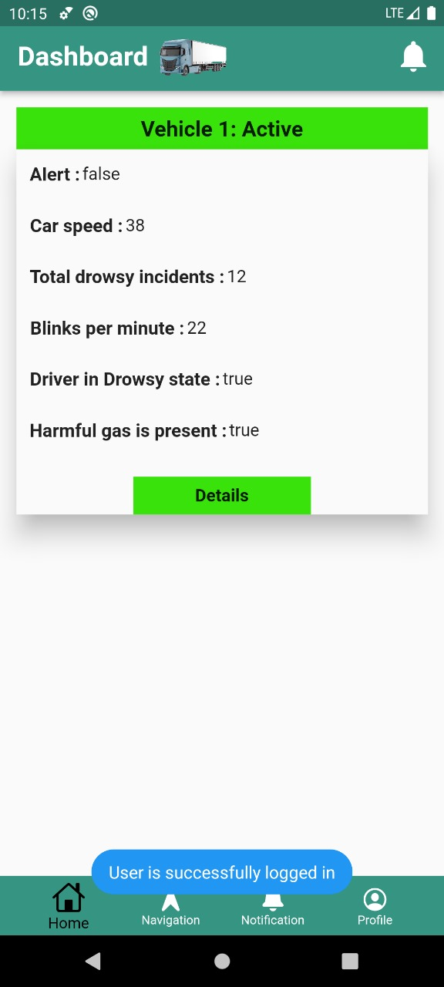

**For Eye Blink Sensor**

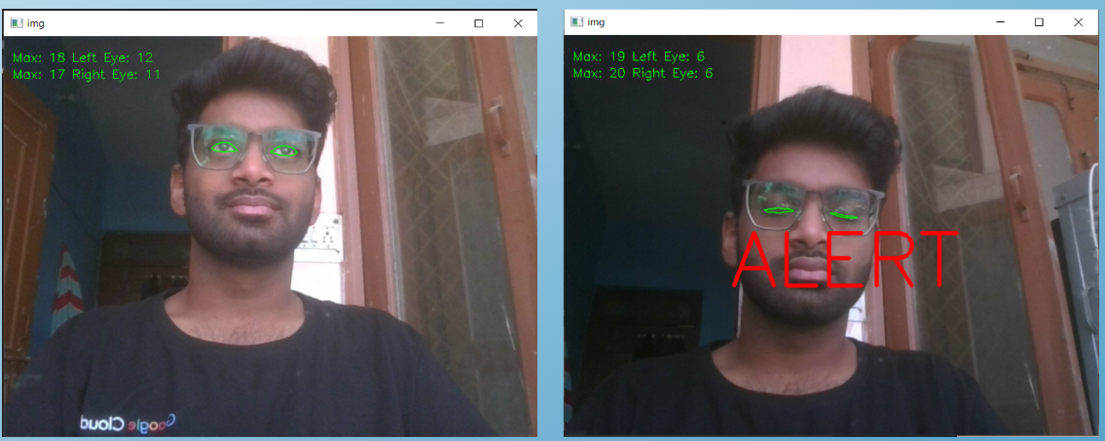

# **Resource & Environment Needs**

## **Testing Tools**

Tools used during testing are:

* **Manual Testing:** A set of test cases were made using BVA, Decision Table and tested by making changes to the backend (Firebase) with the input test data for testing of the App.
* **Comparative Testing:** Sensors used during testing were tested against the Industry level sensors that are already in use.

## **Test Environment**

Requirements of IoT Device include

* Good WiFi connection that has Access to the Internet.
* Constant +5V Supply to keep the IoT hardware running.

Requirement of Flutter-based Android Application:

* Android 5.0+
* Minimum 512 MB RAM, 100 MB Storage
* Steady Internet Connection

# **Terms/Acronyms**

Make a mention of any terms or acronyms used in the project

| **TERM/ACRONYM** | **DEFINITION** |
| --- | --- |
| API | Application Program Interface |
| AUT | Application Under Test |
| BVA | Boundary Value Analysis |
| MB | MegaByte |
| IoT | Internet Of Things |